3-25 Main Question (สำหรับแสดงข้อสอบ)

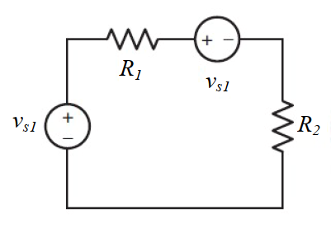

Given *VS*1 = -8 V, *VS* 2 = 16 V, *R*1 = 1 Ω, *R*2 = 4.7 Ω.

Find

Variables (สำหรับเขียนโค้ดเพื่อหาคำตอบ)

Random variables

VS1 = {5:10}; VS2 = {5:10};

R1 = {1:5}; R2 = {1:5}; R3 = {1:5};

Global variables

VS1 = 8; VS2 = 16; R1 = 1; R2 = 4.7;

I = (-VS1-VS2)/(R1+R2);

Part (กรอกคำตอบ)

1. *I* = I = -4.21 A

3-26 Main Question (สำหรับแสดงข้อสอบ)

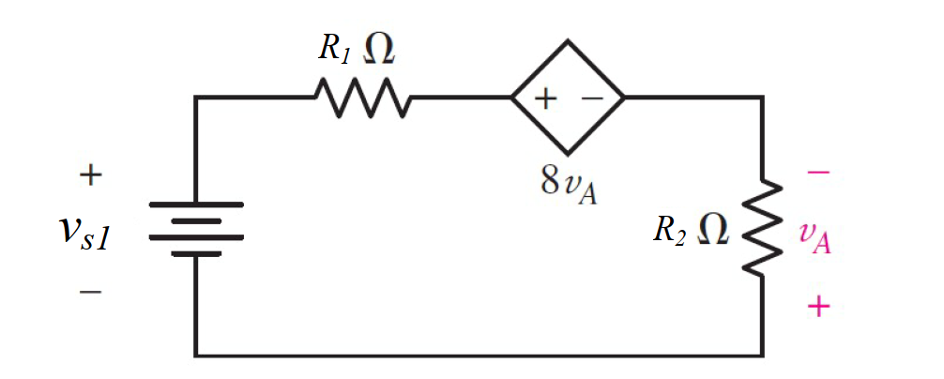

Given *VS*1 = 4.5 V, *R*1 = 2 Ω, *R*2 = 5 Ω,

Find

Variables (สำหรับเขียนโค้ดเพื่อหาคำตอบ)

Random variables

VS1 = {5:10};

R1 = {5:10}; R2 = {1:5};

Global variables

VS1 = 4.5; R1 = 2; R2 = 5;

I= VS1/(R1+R2-8\*R2);

Part (กรอกคำตอบ)

1. *I* = I = -136mA

3-27 Main Question (สำหรับแสดงข้อสอบ)

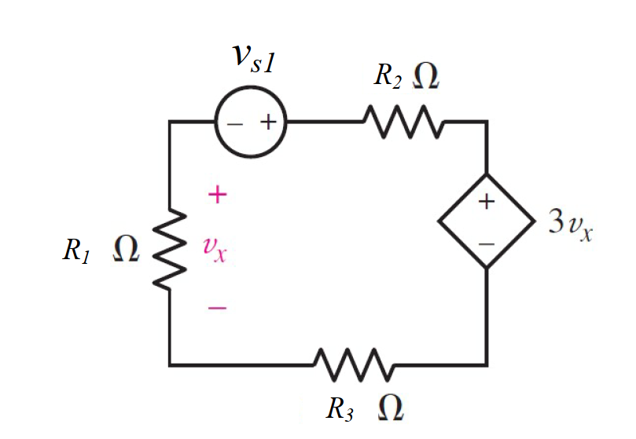

Given *VS*1 = 2 V, *R*1 = 500 Ω, *R*2 = 1000 Ω, *R*3 = 2200 Ω,

Find

Variables (สำหรับเขียนโค้ดเพื่อหาคำตอบ)

Random variables

VS1 = {2:10};

R1 = {100:500:100}; R2 = {100:2000:100}; R3 = {1000:3000:100};

Global variables

VS1 = 2; R1 = 500; R2 = 1000; R3 = 2200;

I = VS1/(R1+R2+R3-3\*R1);

Part (กรอกคำตอบ)

1. *I* = I = 909.1 µA

3-28b Main Question (สำหรับแสดงข้อสอบ)

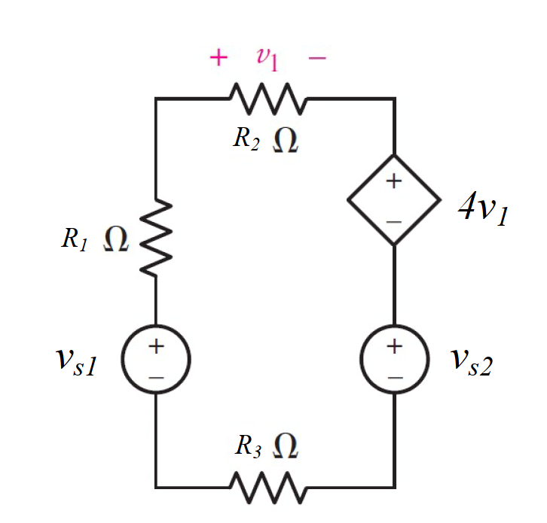

Given *VS1* = 12 V, *VS2* = 2 V, *R*1 = 27 Ω, *R*2 = 33 Ω, *R*3 = 19 Ω,

Find

Variables (สำหรับเขียนโค้ดเพื่อหาคำตอบ)

Random variables

VS1 = {5:10}; VS2 = {5:10}

R1 = {10:30}; R2 = {10:30}; R3 = {10:30};

Global variables

VS1 = 12; VS2 = 2; R1 = 27; R2 = 33; R3 = 19;

I1 = (VS1-VS2)/(R1+R2+R3+4\*R2);

Part (กรอกคำตอบ)

1. *I* = I = 47.4 mA

3.28c Main Question (สำหรับแสดงข้อสอบ)

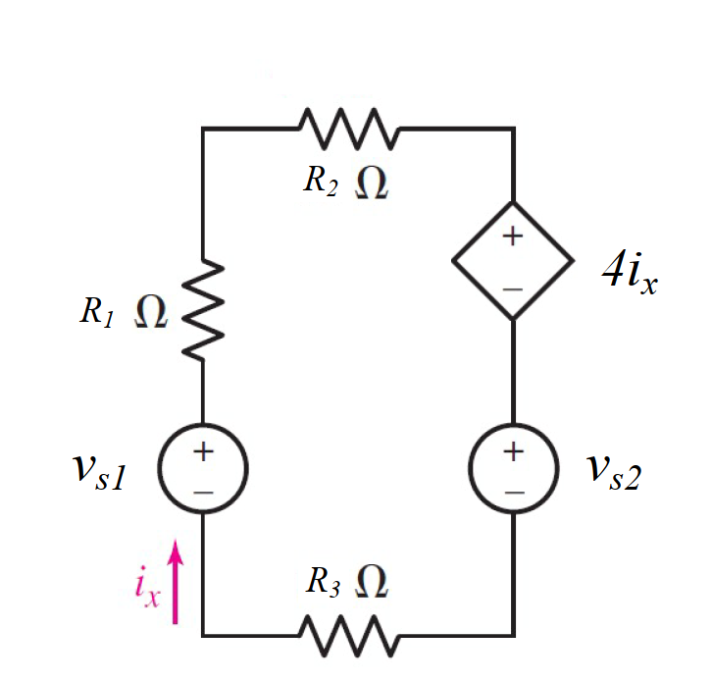

Given *VS1* = 12 V, *VS2* = 2 V, *R*1 = 27 Ω, *R*2 = 33 Ω, *R*3 = 19 Ω,

Find

Variables (สำหรับเขียนโค้ดเพื่อหาคำตอบ)

Random variables

VS1 = {5:10}; VS2 = {5:10}

R1 = {10:30}; R2 = {10:30}; R3 = {10:30};

Global variables

VS1 = 12; VS2 = 2; R1 = 27; R2 = 33; R3 = 19;

Ix = (VS1-VS2)/(R1+R2+R3+4);

Part (กรอกคำตอบ)

1. *Ix* = Ix = 120.5 mA